Grammar Diagnostic
NAME ______________________________ Date ____________________
Finish filing in the chart with the correct verb tense. A few have been done for you.
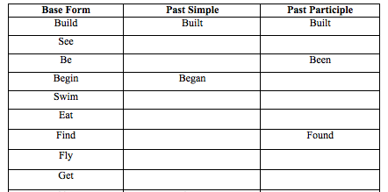
Circle the correct form of the verbs in parentheses.
- While Emily (drove, was driving) on the freeway, her car ran out of gas.
- When Stacy (heard, was hearing) the joke, she laughed.
- My ball (rolled, was rolling) across the street when the car hit it.
- The reporter (asked, was asking) many questions at the press conference yesterday.
- Lisa (traveled, was traveling) on business when she heard the news about her boss’ illness.
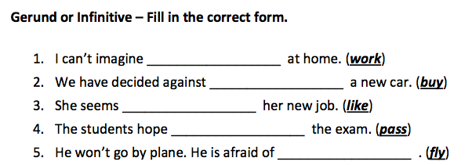

Fill in: The, a, an or --- (leave blank)

1. I have just had _________ great idea.

2. That’s _________ best book I’ve ever read.

3. I ate _________ mango for lunch.
4. _________ People who live in USA are called _________ Americans.
5. Did you read _________ book I gave you last week?
6. Sally went to _________ prison to visit her husband.
7. I bought _________ book last night.
8. Dancing is _________ more interesting activity than reading.
9. This is exactly _________ job I was looking for.
10. Can you hand me _________ apple? Any one will do.

Which sentences are correct? Put a check mark by the ones that are grammatically correct.
Leave the ones that are wrong blank. (You do not need to fix them.)

Part A
_______ 1. They left the class without you and I.

_______ 2. The house belongs to he.

_______ 3. She is a friendly person.

_______ 4. Your children can stay with me for the weekend.

_______ 5. Him should talk more often.

_______ 6. Anyone can offer he or she opinion.

Part B
_______ 1. I’m going to buy egg.

_______ 2. Please help me correct the grammars in my paper.

_______ 3. We have been to the museum four times.

_______ 4. I would like to have many car.

_______ 5. Did the traffics slow you down?

Part C
_______ 1. He come yesterday.

_______ 2. Did you take a lunch?

_______ 3. I will go to work later.

_______ 4. I very like to go to the movies.

_______ 5. He is difficult to learn English.

_______ 6. It’s easy for her to cook.

WRITING SAMPLE
Instructions
As quickly as you can, brainstorm some ideas about the topic below. You should spend no more than 5 minutes on brainstorming. (You can brainstorm on the back if you want.

You will have 25 minutes to write one paragraph about the given topic. You are welcome to write more than one paragraph, but you must have at least one solid paragraph. Do your best! Show me what you know!

Please write legibly (clean and clear).
Write a paragraph about your favorite hobby (something you like to do). When did you first learn to do this hobby? Why is it your favorite? How often do you do this activity? Do you need more than one person to do this hobby? Etc.

Title: _________________________________

_______________________________________________________________________________________________

_______________________________________________________________________________________________

_______________________________________________________________________________________________

_______________________________________________________________________________________________

_______________________________________________________________________________________________

_______________________________________________________________________________________________

_______________________________________________________________________________________________

_______________________________________________________________________________________________

_______________________________________________________________________________________________

_______________________________________________________________________________________________

_______________________________________________________________________________________________

______________________________________________________________________________________________

